|  |  |  |
| --- | --- | --- |
| The Eleventh Sunday In Ordinary Time | June 16, 2024 |  |

|  |  |  |  |
| --- | --- | --- | --- |
| **Mass Intentions** | | | |
| June | 17 | 8:00 AM | **NO MASS** |
| June | 18 | 8:00 AM | **Betty Rhodes requested by Pat & Glenn Harshberger** |
| June | 19 | 8:00 AM | **Mike & Kathy Brennan requested by Jerry & Karen Kupris** |
| June | 20 | 8:00 AM | **Long Dinh requested by Kathy Raugh** |
| June | 21 | 8:00 AM | **Cathy Shulna** |
| June | 22 | 5:00 PM | **People Of The Parish** |
| June | 23 | 9:00 AM | **Tony Forlizzi requested by Antoinette Scotta** |
|  |  |  |  |
|  |  |  |  |
|  |  |  |  |

|  |  |  |  |
| --- | --- | --- | --- |
| Liturgical Ministries June 22-23 | | | |
|  | **Lectors** | **Extraordinary Ministers** | **Servers** |
|  |  |  |  |
| 5:00 PM | Sue Guarducci | Yvonne DePaulis | Helena Krieger |
|  |  |  |  |
|  |  |  |  |
|  |  |  |  |
|  |  |  |  |
| 9:00 AM | Julie Richelderfer | Bill Davies | The Morrison Family |
|  |  |  |  |
|  |  |  |  |
|  |  |  |  |

|  |  |  |
| --- | --- | --- |
| Schmidt Center Cleaning | | |
|  | | |
| **June 23** | The Raugh Family |  |
|  |  |  |
| **June 30** | Jim DiPofi & Tonya Sands |  |
|  |  |  |

|  |  |  |
| --- | --- | --- |
| Next Sunday’s Readings | | |
| *Please prepare for Mass and the Homily by reflecting on these texts from the Sacred Scriptures* | | |
|  |  |  |
| **Job** 38:1, 8-11 | **2 Corinthians** 5:14-17 | **Mark** 4:35-41 |

|  |
| --- |
| Christian Stewardship |
| **Last Sunday’s Collection amounted to:** $4,993.79 |
| **The Collection on this date one year ago amounted to:** $4,964.00 |
|  |
| May God Bless you for your generous and responsible stewardship!!! |

From the Pastor’s Desk:

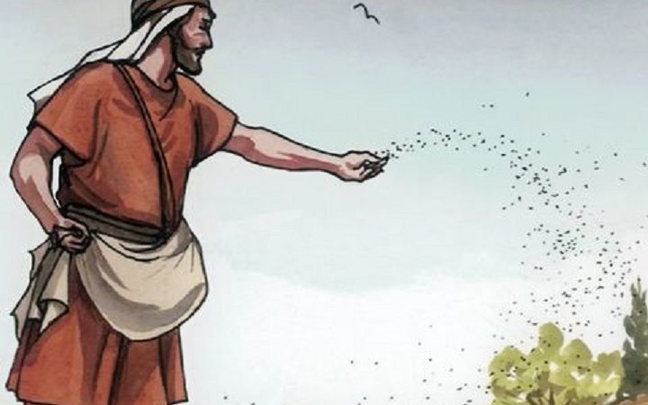 If we walk through the woods on a beautiful spring day, we’ll see the signs of life bursting forward. Green shoots coming up from the ground, leaf buds poking out from the branches of a tree – even the birds and animals are busily scampering. Life, growth, and new beginnings are all around. Today’s readings have a common theme of nature as one of the ways we can experience God’s design. Like the crowds Jesus taught, we may not know the exact cause of what makes a plant grow from a tiny seed to a towering tree, but that’s OK – we don’t have to know. As St. Paul writes, “we walk by faith, not by sight.” We trust the Lord to lead and guide us. And, like the harvester in the parable, we can observe, tend, and act when the time is right to bring in the harvest, for, as Paul continues in his letter: “We aspire to please [God].”

Church Calendar

***Sunday, June 16th (Happy Father’s Day)***

Confessions, 7:00-7:45AM

Mass, 9:00AM

***Monday, June 17th***

No Mass

***Tuesday, June 18th***

Mass, 8:00AM

***Wednesday, June 19th***

Mass, 8:00AM

Prayer Group, 8:30AM

***Thursday, June 20th***

Mass, 8:00AM

***Friday, June 21st***

Mass, 8:00AM

***Saturday, June 22nd***

Confessions, 4:00-4:45PM

Sunday Vigil Mass, 5:00PM

***Sunday, June 23rd***

Confessions, 8:00-8:45AM

Mass, 9:00

“The seed is the word of God, Christ is the Sower.”

What does it look like to play an active role in bringing in the harvest? Faith is a lifelong journey, and everyone is in a different place. The delicate shoot needs different care than the full-grown tree. In prayer, God can speak to us to help us discern the best way to help the people he has put in our lives. Perhaps we offer encouragement, or a shoulder to lean on. Maybe someone needs a friend to converse with. No matter where or who we are, each one of us can be like the harvester that Jesus references, observing and acting as appropriate, helping support the seed of faith God plants in each person. And as we heard in the Gospel today, the smallest seed can become the largest of plants; therefore, our work is plentiful as laborers working to help build God’s kingdom here on earth.

Pray for the wisdom to recognize where you are in your journey, what you need to keep growing, and how you can offer to help others.

Remember the Sick of our Parish in your charity and prayers: John Kapp, Rosemary Anderson, Cathy Steiner, Marietta McQuaid, Marie Dishman, Suzanne Matunis, Jeanette Fasick, Pat Widdowson, Kay Dorundo, Gene Odato, Annetta Round, Joann Speis, Joni Lawrence, Shirley Scotta, Samantha Strazisar, Ellen White, and all the long-suffering in our community and at Perry Village.

Deacon Robinson’s Contact Information: Contact Deacon Robinson at his cell phone **(602-6298)** or deacon.robinson@anologyapologetics.com.

Online Information: You can access the weekly bulletin and other information at our parish website ([www.stbernardsnbpa.org](http://www.stbernardsnbpa.org)).

Saint Bernard’s Garden Club: To keep our parish property looking its best during the summer months, families are asked to assist by taking a portion of our property and keeping it weeded and trimmed throughout the summer. It only takes a little of your time (a few times a month) to keep our parish looking well kept the whole summer long. Thank you for all you do for our parish family.

Vacation Bible School: St Bernard's will host a VBS program about the Holy Eucharist for children aged 3 to entering the 6th grade from July 22 through July 26, 2024, 6 PM - 8:30 PM. Registration forms are available from CCD or the bulletin board in the narthex. Please complete them and return as soon as possible. Older students are welcome to join us and assist with the activities - this is a great way to complete service hours. If you have any questions, please contact Jen Morrison @ 717-462-4556, morrisonfam10@gmail.com, or 717-254-0280 (text).

CCD Teacher/Catechist Opportunity: Are you interested in working with the children in our religious education classes as a teacher or aide but unsure of your ability to teach or if you possess enough knowledge of our Catholic faith? ***Just your willingness to pass along a living faith to the youth of our parish is one of the most important characteristics of a good catechist.*** Our classes are teamed with 2 catechists and the younger classes also have an aide. We need aides in grades 1st and 4th and a teacher in 5th. Alice Vilk will meet with any interested persons to discuss our program, the text we use, and the duties and responsibilities of our teachers and aides. If interested, please email Alice Vilk at alicevilk4@gmail.com. It takes many caring individuals to educate the students of our parish, so come join us!

[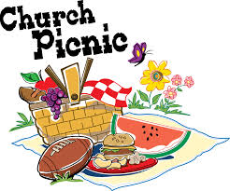](http://www.google.com/url?sa=i&rct=j&q=&esrc=s&frm=1&source=images&cd=&cad=rja&uact=8&ved=0ahUKEwim8oaG7KnNAhVYDlIKHb_tD4IQjRwIBw&url=http%3A%2F%2Fwww.mccoybaptist.org%2Fchurch-picnic%2F&psig=AFQjCNFNcZB1FjUziiRxEQjk2xuW4T_F8A&ust=1466073627425672)Parish Picnic: Mark your calendars now for our Parish Picnic. It is scheduled for Sunday, August 4th from 1:00 to 4:00PM at the parish pavilion. Families are asked to bring a vegetable dish, salad, or dessert. Our gracious Knights of Columbus will provide the meat course and drinks. It is a fun time for everyone and early enough in August for our college bound youth to enjoy before heading off to school. Please sign up at the bulletin board if you plan to attend!

A sense of decorum in dressing for Church: The summertime can be hot and humid and often calls for clothing that is more comfortable. There is, however, a proper decorum to be used when considering the clothing we wear for Mass and church. While fancy Sunday-best dresses/hats or suit and tie may not be the attire we wear in the “causal” atmosphere of today’s society, there is always a need to monitor closely what we wear because it reflects on us, our values, and the importance we place on our respect for God and our neighbor. We have no church dress codes we can look to except the one dictated by the virtue of modesty and good taste. In general, we should avoid the following when dressing for church: ***Spaghetti straps/tank tops, bare backs or shoulders, sleeveless shirts or plunging necklines, tubes, skimpy skirts or shorts, low waist pants, Jersey shorts/gym wear, caps or flip-flops.*** Thank you for your consideration!

Father’s Day Reflection: While not a liturgical observance, Father’s Day is a wonderful time to recall the essential role of fathers in the life of the family and in building a culture of life. It is also an opportunity to highlight spiritual fatherhood, which all men are called to embrace. Fathers are called in a special way to reflect God’s unconditional love and forgiveness. Similar to the way our heavenly Father cares for us, our earthly fathers are there to help us navigate life’s challenges and pick us up when we fall.

Jesus Christ provides an example of the very vocation of fatherhood. Fathers sacrifice for their families.

They do this by:

• Being the spiritual leaders and guardians of their families.

• Praying for and with their families.

• Being a courageous witness to the Gospel.

• Providing care and support for their families.

• Serving as an example of goodness and truth.

• Leading with courage and accountability.

• Laying down one’s life for the other.

Today, in a special way, let us be grateful for:

• Our fathers, by birth or adoption, who love us and support us through life.

• Our priests and bishops who act as spiritual fathers.

• God our Father, who will always teach justly and grant us boundless mercy.