|  |  |  |
| --- | --- | --- |
| The Third Sunday Of Advent | December 17, 2023 |  |

|  |  |  |  |
| --- | --- | --- | --- |
| **Mass Intentions** | | | |
| December | 18 | 8:00 AM | **Bill Sheaffer requested by John & Mary Blair** |
| December | 19 | 8:00 AM | **Mike Lanis requested by Saint Bernard Knights of Columbus** |
| December | 20 | 8:00 AM | **Craig Pugh requested by The Pugh Family** |
| December | 21 | 8:00 AM | **Patty Frye requested by The Raugh Family** |
| December | 22 | 8:00 AM | **Intentions Of Magdalene Fordyce requested by Her Family** |
| December | 23 | 5:00 PM | **People Of The Parish** |
| December | 24 | 9:00 AM | **Debbie Corson requested by Mark & Ginny Ticehurst** |
|  |  | 4:00 PM | **People Of The Parish** |
|  |  | 6:00 PM | **Deceased Of The King and Sharman Families** |
| December | 25 | 9:00 AM | **Megan Moyer Seiber requested by The Moyer Family** |

|  |  |  |  |
| --- | --- | --- | --- |
| Liturgical Ministries December 23-24-25 | | | |
|  | **Lectors** | **Extraordinary Ministers** | **Servers** |
|  |  |  |  |
| 5:00 PM | Sue Guarducci | Gwen Pray | Terry Meek |
|  |  |  |  |
| 9:00 AM | David Pray | Scott Sheaffer | Helena Krieger |
|  |  |  |  |
| 4:00 PM | Joe Dailey | Bill Davies | The Morrison Family |
|  |  |  |  |
| 6:00 PM | Sean Romano | Mark Ticehurst | The Robinson Family |
|  |  |  |  |
| 9:00 AM | Jeff Aro | Scott Dunkelberger | Anna & Julia Sheaffer, Helena Krieger |

|  |  |  |
| --- | --- | --- |
| Schmidt Center Cleaning | | |
|  | | |
| **December 10** | Madeline Rogers & Pat Harshberger |  |
|  |  |  |
| **December 17** | Gabby Brandt & Jen Meek |  |
|  |  |  |

|  |  |  |
| --- | --- | --- |
| Next Sunday’s Readings | | |
| *Please prepare for Mass and the Homily by reflecting on these texts from the Sacred Scriptures* | | |
|  |  |  |
| **Isaiah** 61:1-2a, 10-11 | **1 Thessalonians** 5: 16-24 | **John** 1:6-8, 19-28 |

|  |
| --- |
| Christian Stewardship |
| **Last Sunday’s Collection amounted to:** $5,072.00 |
| **The Collection on this date one year ago amounted to:** $6,245.00 |
|  |
| May God Bless you for your generous and responsible stewardship!!! |

Church Calendar

***Sunday, December 17th (3rd Sunday of Advent)***

Confessions, 7:00-7:45AM/9:45-10:15AM

Masses, 8:00AM and 10:30AM

CCD, 9:15-10:15AM

***Monday, December 18th***

Mass, 8:00AM

***Tuesday, December 19th***

Mass, 8:00AM

***Wednesday, December 20th***

Mass, 8:00AM

Prayer Group, 8:30AM

***Thursday, December 21st***

Mass, 8:00AM

***Friday, December 22nd***

Mass, 8:00AM

***Saturday, December 23rd***

Church Decorating for Christmas, 8:00AM

Confessions, 4:00-4:45PM

Mass, 5:00 PM

***Sunday, December 24th (4th Sunday of Advent)***

Confessions, 8:00-8:45AM

Mass, 9:00AM

No CCD

Christmas Eve Masses, 4:00 and 6:00PM

***Monday, December 25th (Christmas Day)***

Mass, 9:00AM

“O Come, O Come, Emmanuel.”

From the Pastor’s Desk:

Today we light the rose Advent candle as we celebrate Gaudete Sunday. Gaudete means “rejoice,” and today’s readings hint at the joy of Christ’s coming. Who among us can’t relate to the concrete examples from the prophet Isaiah that give us many reasons for hope and joy as we anticipate Christ’s birth. Those of us who have experienced fear or doubt find reassurance: “Be strong, fear not!” During the holidays when many will grieve those who have died this past year, we hear that “sorrow and mourning will flee.” In today’s Gospel, John the Baptist points us to the source of our joy in the person of Jesus Christ. As we continue to prepare for his coming, we can take comfort knowing that God is with us now and for eternity. As we hear in today's Psalm, "The Lord God keeps faith forever.” We are not patient people. Waiting in the slow grocery line raises our heart rate, and we have to use cruise control in 35 mph zones. Despite our impatience, there are still things in life that we do that take time, like planting vegetable gardens in the spring. As St. James reminds us, we can learn from the farmer who patiently waits for the rains. “You too must be patient. Make your hearts firm, because the coming of the Lord is at hand.” Whether we have patient personalities or not, we can rest assured that the Lord is with us for the long haul. Just as the rains help our tomatoes to come in our faithfulness, prayer, and good works can nurture our hearts and our souls. They also remind us of the true joy of the season: Our Savior, Jesus Christ, has taken on our humanity for our salvation. “Lord, come and save us.” Need something to brighten your living area during the deep of winter? You can find amaryllis “bulbs in a box” online. They bloom inside and can be moved outside when spring comes, serving as a visible reminder that patience pays off. This can also be a nice gift for a friend or perhaps an elderly relative who does not have access to a garden.

Remember the Sick of our Parish in your charity and prayers: John Kapp, Rosemary Anderson, Cathy Steiner, Marietta McQuaid, Marie Dishman, Suzanne Matunis, Jeanette Fasick, Pat Widdowson, Kay Dorundo, Mike Brennan, Gene Odato, Annetta Round, Marian Shatto, Joann Speis, Joni Lawrence, Shirley Scotta, and all the long-suffering in our community and at Perry Village.

Deacon Robinson’s Contact Information: You may contact Deacon Robinson at his cell phone **(602-6298)** or through his email: [**dcnrobin@ptd.net**](mailto:dcnrobin@ptd.net)**.**

Online Information: You can access the weekly bulletin and information at our parish website at www.stbernardsnbpa.org.

Remember: The mood of the Advent season is one of somber spiritual preparation that increases in joy with each day that draws us closer to the celebration of the Nativity of the Lord. So, the worldly “Christmas” commercialism that surrounds it in the Western world should be overcome as much as possible. We should strive to keep the liturgical season of Advent holy, penitential, reflective, and prayerful, always remembering, as they say, that “He is the reason for the Season.” Jesus came once in the flesh; He comes to us now in spirit and power through His Word and His sacraments; He will come again in glory at the end of the age!

[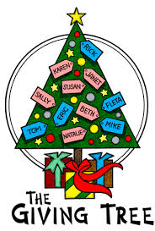](http://www.google.com/imgres?q=christmas+giving+tree&hl=en&sa=X&tbo=d&qscrl=1&rlz=1T4WZPC_enUS409US411&biw=1398&bih=718&tbm=isch&tbnid=Y8QON-tARRbCpM:&imgrefurl=http://www.marywood.edu/calendar/event-detail.html%3Fid%3D5ed81e50-f3fb-4117-899a-b88e1ec73106&docid=h_jaLHRJkja6qM&imgurl=http://www.marywood.edu/dotAsset//dotAsset/933811a7-65a9-4f32-a122-f65b8a54d325.jpg&w=338&h=500&ei=Z8qrUN7sB6fO0QH19YCABA&zoom=1&iact=hc&vpx=2&vpy=141&dur=7745&hovh=273&hovw=184&tx=92&ty=165&sig=102161500938280082631&page=1&tbnh=129&tbnw=87&start=0&ndsp=28&ved=1t:429,r:0,s:0,i:87)The Mitten Tree: Each year at Christmas, our parish reaches out to our own parish family and the community and provides approximately 100 gifts for those less fortunate. Again, this year, everyone is invited to select an ornament from our Mitten Tree and fulfill a Christmas wish for the needy. For many people, these are the only gifts they will receive. The Mitten Tree is located at the main doors of the Church. Only one gift per tag!! **Your gifts should be returned by Sunday, December 17th**.

Christ in Christmas Cards designed by our CCD students are being offered for sale by our Knights of Columbus. The cost is $8.00 for an assorted package of 15 cards, and you can purchase them at the kitchenette.

Be Considerate of Others: In consideration of parishioners listening to the readings from Sacred Scripture or to the homily, or if people are kneeling during the consecration of the Mass, please wait until the congregation stands to seat yourself. Walking down the aisle while everyone is seated and listening to the readings or homily is very distracting. If you are late for Mass *(which sometimes cannot be helped)* or if you need to leave Mass for some reason, please return to your seat only when the congregation stands! This will help eliminate distractions during Mass for parishioners and the celebrant.

# Christmas Masses

Sunday Masses

December 23/24th

Saturday, December 23rd at 5:00PM

Sunday, December 24th at 9:00AM

Christmas Eve Masses

Sunday, December 24th

4:00PM and 6:00PM

Mass on Christmas Day

Monday, December 25th

9:00 AM

Use of Parish Kitchen and Facilities: In accordance with the norms of our insurance company, Catholic Mutual, a person must be 16 years old to work or enter the kitchen. If parishioners want to use the kitchen or other parish facilities, which you are always free to do, please reserve the space with the parish office and sign the insurance form at least one week before your event. If your event is parish related, no additional insurance is needed. If personal, you must secure additional insurance from your own insurance company or through Catholic Mutual in case of accidents or physical harm. Call the parish office for further information.

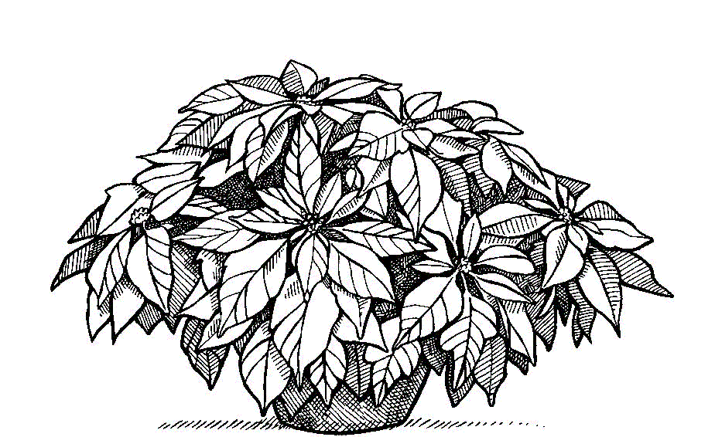Church Decorating for Christmas: Your gracious assistance is needed to help decorate our church on Saturday, December 23rd at 8:00AM with the Christmas trees and poinsettias that beautify our sanctuary. Please sign up at the bulletin board if you can assist us.

Rest in Peace: In your charity and prayers remember the souls of Donald Shaeffer, Sr., who died on Sunday, December 10th, and Kathleen Brennan, who died on Wednesday, December 13th. May God grant these faithful servants a merciful judgment and admit them to the Kingdom of light, joy, and peace! May He also give healing and consolation to their families!

Parish Contribution Statements for your church offerings will be available in early January. If you would like to have a statement emailed to you, please contact the parish office (info@stbernardsnbpa.org) and request one. Paper statements will also be available upon request.