The Twenty-Fifth Sunday In Ordinary Time | September 18, 2022

Mass Intentions
September | 19 | 8:00 AM | NO MASS
September | 20 | 8:00 AM | Charlotte Smith requested by Reid & Judy Wilson
September | 21 | 8:00 AM | Deceased Of The Ondriezek Family requested by The Dixon Family
September | 22 | 8:00 AM | Intentions Of Magdalene Forydce requested by The Fordyce Family
September | 23 | 8:00 AM | Gertude Mangan requested by Michael Pray
September | 24 | 5:00 PM | David Raugh requested by The Raugh Family
September | 25 | 8:00 AM | People Of The Parish
 |  | 10:30 AM | Roberto Guarducci requested by Sue Guarducci

Liturgical Ministries September 24-25
 | Lectors | Extraordinary Ministers | Servers
5:00 PM | Joe DeFrancesco | Dave Suydam | The Fordyce Family
8:00 AM | Scott Sheaffer | Scott Dunkelberger | The Robinson Family
10:30 AM | Julie Richelderfer | Mark Ticehurst | The Morrison Family

Schmidt Center Cleaning
September 25 | Madeline Rogers & Pat Harshberger
October 1-2 | The Hoffman Family

Next Sunday’s Readings
Please prepare for Mass and the Homily by reflecting on these texts from the Sacred Scriptures
Amos 6:1a, 4-7 | 1 Timothy 6:11-16 | Luke 16:19-31

Christian Stewardship
Last Sunday’s Collection amounted to: $5,529
The Collection on this date one year ago amounted to: $5,875.05
May God Bless you for your generous and responsible stewardship!!!

Church Calendar

Sunday, September 18th
Mass, 9:00AM
Monday, September 19th
No Mass
PA March for Life, 12PM (at the Capital)
Tuesday, September 20th
Mass, 8:00AM
Wednesday, September 21st
Mass, 8:00AM
Thursday, September 22nd
Mass, 8:00AM
Friday, September 23rd
Mass, 8:00AM
Saturday, September 24th
Confessions, 4:00-4:45PM
Mass, 5:00PM
Sunday, September 25th
Masses, 8:00 and 10:30AM
CCD, 9:15-10:15AM

“Though our Lord Jesus Christ was rich, He became poor,
so that by His poverty
you might become rich.”
From the Pastor’s Desk
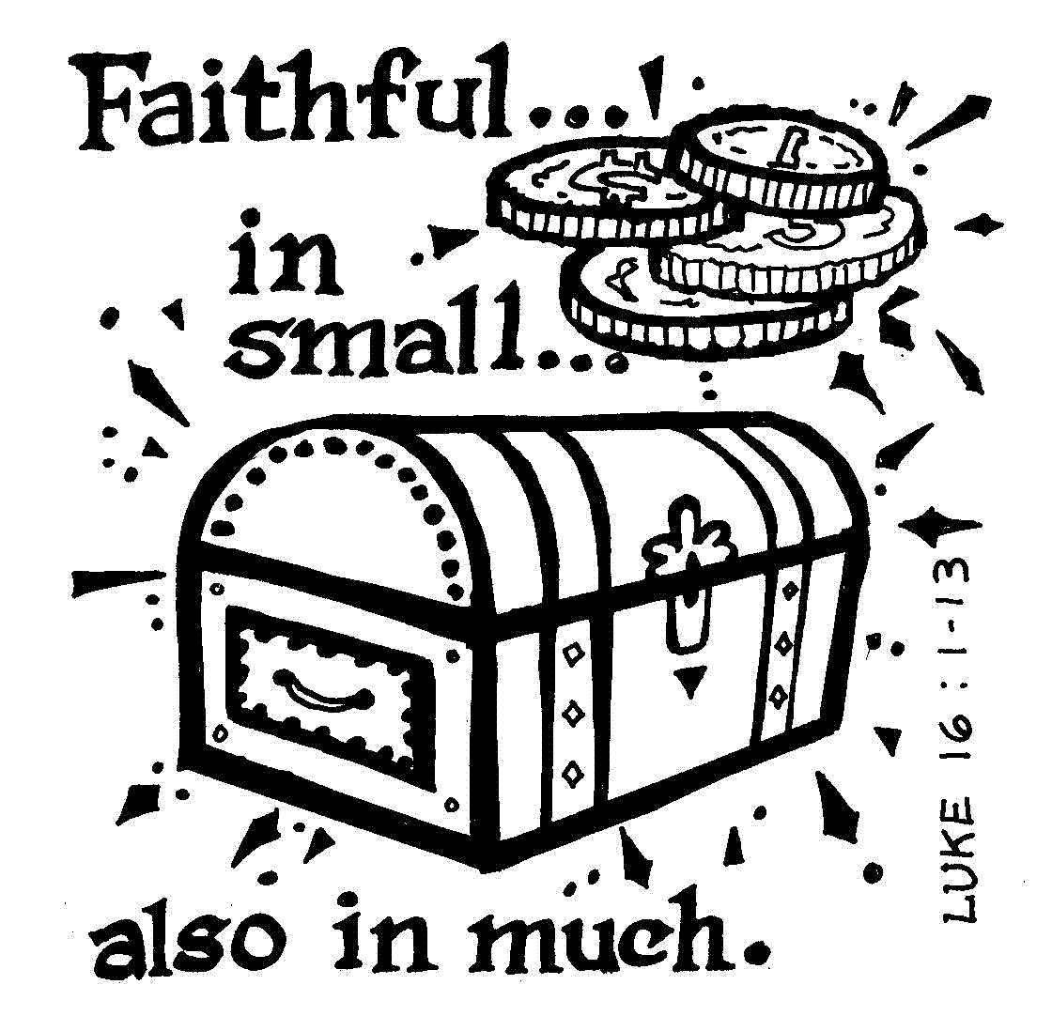
Some tasks are just too big to face all at once. Major projects like moving to another city, renovating your home, starting a totally new career can make us feel overwhelmed with all there is to be done. When we stare down that long road of detail after detail we’re sure it’ll never be finished. If our eyes stay focused on that daunting picture for too long, we’ll succumb to despair and quit before we’re even started. How many dreams have we decided are impossible without even trying?
Living a truly committed, spirit filled Christian life can feel a bit like that. How can we be sure not to stumble on the way? But what we forget is it’s not about the big picture. Jesus wants us to be faithful in the small things first. Those little do-able daily challenges. As Jesus teaches us in today’s gospel, when a servant is faithful in the small things, they will be faithful in the greater things too. To prove ourselves ready for bigger tasks, we must choose God’s way instead of the world, in all the little decisions we make. Each small step of faith taking us closer to Him, closer to the true and trusted servant He knows we can be.

Remember the Sick of our Parish in your charity and prayers: John Kapp, Jane and Dennis Haag, Bill Sharman, Kay Dorundo, Joni Lawrence, Cathy Steiner, John and Sue Cover, Bill Selle, Diana Prowell, Marietta McQuaid, Tom Mellis, Marie Dishman, Suzanne Matunis, Judy and Joe Rich, Jeanette Fasick, Mike Landis, Greg Nye, and all the long-suffering in our community and at Perry Village.

Deacon Robinson’s Contact Information: You may contact Deacon Robinson at his cell phone (717-602-6298) or through his email: dcnrobin@ptd.net.

Online Bulletin: www.stbernardsnbpa.org

Parish Historical Pictures Needed: As we prepare to celebrate the 75th Anniversary of our parish in October 2023, we need historical pictures from the 1980’s, 1990’s, and the 50th Anniversary of our parish, which took place in 1998. If you have pictures you would like to share, please put them in an envelope, clearly marked with your name and address. Once scanned, they will be returned to you. Our parish is trying to create a data base of pictures for use on our narthex video display. They will be grouped together and presented throughout the anniversary year. Some pictures may also be used in a commemorative booklet. It would help if you can identity the event or persons depicted on the back of the picture. You can deposit your photos in the box in the narthex. Thank you for your assistance with this project!

PA Pro-Life March: Make plans to join the 2nd annual Pennsylvania March for Life on Monday, September 19th! The main events include a huge rally at 11 AM followed by the march around the PA State Capitol at 12 noon. March for Life’s Jeanne Mancini is one of the confirmed speakers along with His Excellency, the Most Reverend Nelson J. Pérez, Archbishop of Philadelphia. More speaker announcements are coming soon! This is an excellent opportunity for anyone to learn about the principles of effective lobbying, the specific and current issues Pennsylvania is facing, and what you can do right now to champion pro-life policies to your PA elected representatives. More details to come!

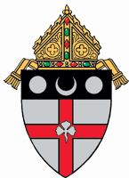
2022 Diocese of Harrisburg Women’s Conference: On Saturday, October 15th, the Diocese will offer our 7th Annual Women’s Conference at the Diocesan Conference Center, 4800 Union Deposit Road, Harrisburg. The day begins with registration at 7:15AM and ends with Mass at 4:00PM. The theme for this year is The Eucharist: Jesus in our Midst. There will be a keynote speaker, workshop sessions, confession, Eucharistic Adoration, Holy Mass, and fellowship with hundreds of women that will refresh your soul as we continue to celebrate our faith in Jesus Christ. Registration is easy and convenient on the Diocesan Web site. Come and see what God’s love can do in your life!

Hospitality Apostolate: This group would like to offer meals to parishioners just released from the hospital, new mothers, and shut-ins who need temporary care. If you can use their services or know someone who can, please contact Phyllis Krieger (kriegerkrew@aol.com/717-834-9433).

Knight of Columbus News:
1. The Knights of Columbus would like to thank all who participated in the Book Sale. It was a great success. The funds collected will support the many projects undertaken by the Knights for their fraternal organization and the life of our Parish.
2. The Knights of Columbus are updating their contact list. If you are a member, please stop by the kitchenette to check and update your contact information.
3. Consider joining the Knight of Columbus Fraternal Organization and share your faith with like-minded men of our parish and help extend the Reign of Christ in our world through prayer, fraternity, and active charity for neighbor. For more information, please contact Grand-Knight Joe Oltheten.

Pro-Life: “Those who would inflict death in the name of mercy are, in effect, claiming that they understand suffering better than the One who died on the cross, that they are more merciful than ‘the Father of compassion and the God of all comfort,’ that they are a better judge of when a life is worthless or expendable than the One who created life in the first place.” (Alan Sears, National Catholic Register, March 5, 2006.)

Children and Mass: Parents are the first educators of their children in the ways of faith and bear a sacred responsibility, assumed at baptism, to raise them to keep the commandments as Christ taught us, by loving God and neighbor. Their participation at Holy Mass enables them to worship God, be nourished by Christ in the Holy Eucharist, and take their rightful place as members of the Church. What they learn in religious education class is reinforced at home by parental example and celebrated in the Sacred Liturgy with their parish family. Please make sure your children attend Mass on Sundays, confess their sins often in Penance, and so mature in their life of faith. Our religious education program can only assist parents in passing along a living faith – but we cannot do so without their conscious decision to fulfill their sacred obligation to raise their children as faith-filled, practicing Catholics.

A Eucharistic Thought: [The Eucharist] is the noblest sacrament, consequently, is that wherein His Body is really, truly, and substantially present. The Eucharist crowns all the other sacraments.” (Saint Thomas Aquinas)

